EA467 Transmission Lines in Space Systems: Rev c Fall 2017

INTRODUCTION: Transmission lines are specialized cables for transferring alternating current radio frequencies (RF) between devices in a communications system. Transmission lines connect not only antennas to transmitters and receivers, but also modules and subsystems. Since frequencies have wavelengths, and transmission lines have physical lengths, the electrical behavior of the line is more complex than that of a wire or low frequency transmission line. This commonly occurs in all radio, microwave, optical and high speed digital circuits. In contrast, common power lines at 60Hz have a wavelength of approximately 5000 km (Remember C = f λ), and thus don’t need to account for transmission line theory effects except in the case of very long distance power lines. However, for any RF, the wavelength in relation to the line length must be taken into account. In practice, conductors of about 1/10 wavelength or longer have a significant reactive impedance as a function of frequency, and this impedance must be addressed in all aspects of system design. Some common terms:

- Characteristic Impedance: Lines have characteristic impedance (Z₀). The characteristic impedance of any medium can be described as the ratio of voltage to current flow in the medium (volts/amps = Ohms). In free space, this equates to the ratio of the electric field magnitude, E in volts per meter, to the magnetic field strength, H, in amps per meter. In a transmission line, Z₀ is the ratio of the complex voltage to the complex current at any point on the line. If the transmission line is uniform along its length, then its behavior is well characterized by its characteristic impedance, Z₀. RF Transmission lines come in a few typical standard impedances. Typical values of Z₀ for coaxial cable are 50 (RG-58) and 75 (RG-59) Ohms. For a twisted pair of wires, about 100 Ohms is typical, and about 300 Ohms for a common type of untwisted pair used in TV anntennas known as “twinlead”.

- Impedance Matching: Impedance matching between a “source” and a “load” is required for maximum transfer of signal and energy. If a transmission line is terminated with impedance different from the line impedance, some of the energy will be reflected and maximum power transfer will not occur

- Voltage Standing Wave Ratio (VSWR): When lines are mismatched with their loads, the resulting reflections combine with the incident wave to set up an interference pattern called a standing wave. Therefore, at certain places the ac voltages will be in phase, and the interference pattern will have maximum voltage amplitude, and at other points the voltages will be out of phase resulting in minimum voltage amplitude. These maximum and minimum points occur ¼ wavelength apart in the transmission line.

The VSWR is defined as the ratio of the maximum to minimum voltage amplitudes in a standing wave pattern. Sometimes simply referred to as SWR, The VSWR is a good quantitative measure of the amount of mismatch in a transmission line. In contrast, when a transmission line is terminated on both ends by impedances that match the Z₀ of the line, then maximum power transfer takes place and SWR is at its minimum (1). VSWR can range from 1 (ideal transfer of power) to infinity, and an SWR of 1.5 or less is a typical goal for real-world communications systems. The SWR is computed using the ratio of reflected to incident (or “forward”) power or voltage, as in the equations below. The Reflection Coefficient is also related to SWR and represents the difference in the Line and Load impedance.

$VSWR=\frac{{\left(1+\frac{P_{ref}}{P_{fwd}}\right)}^{\frac{1}{2}}}{{\left(1-\frac{P_{ref}}{P_{fwd}}\right)}^{\frac{1}{2}}}$ (1)

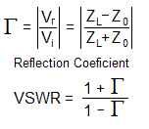
(2)

(3)

Variable Definition for equations above:
P_{ref} = Reflected Power P_{fwd} = Forward Power
V_{r} = Voltage Reflected V_{i} = Voltage Incident
Z₀ = Characteristic Impedance Z_{L} = Load Impedance

- Loads: The impedance of any device connected to a transmission line can be described by the real and reactive components of its impedance, R + jX in Ohms. Designers want loads to be a real R resistance (preferably that matches the Z₀ or the lines), and matched (X term near zero) so that maximum power is transferred and minimum power is reflected.

- Loss: All lines also have resistance loss, and so the objective of system design is to minimize the effects of those losses. Low loss lines are expensive and usually big. Lines are typically kept as short as practical to minimize loss.

- Bandwidth: Due to variations in transmission line impedance with frequency and length, most RF systems only work to design specification over a specific range of frequencies. This range of frequencies is called the bandwidth of the system and is often defined as the frequency limits where SWR is below 2.0 or ideally below 1.5.

- Velocity Factor: Radio waves at the speed of light are slowed by the dielectric constant of the insulating material in a transmission line. Typical velocity factors are 66%, 81% and 89%. This factor shortens the effective length of the line. For example, a ¼ wave at 150 Mhz is 12” in coaxial cable instead of 18” in air.

- Connectors: There are a few common RF connectors you should recognize. BNC are the twist-lock connectors typically seen on small coax in labs. SMA are smaller, usually brass colored and screw-on usually used in space systems. Larger cables or those carrying higher power use type “N” connectors (on our wattmeter and Signal Generators). The common 70 year old PL-259 is used on CB sets and are often called UHF connectors though they are rarely used above VHF because the fat center pin makes a bump in the impedance of the line.

- Length: A matched line can be any length and remain matched. However, a non-matched line will have standing waves that will transform the impedances at the ends anywhere on the complex plane between a short (0 resistance) and an open circuit (infinite resistance) depending only on variations in length. For example, an Open line will appear as a short ¼ wave down the line. A shorted line will appear as an open, ¼ wave away. This transformation of impedance being dependent on length can be used as an advantage for tuning and matching lines, for example to transform complex impedances at one end of a line to a more desirable impedance at the other. This is why transmission line length can be very significant in some designs. Matching can also use discrete inductive and capacitive (L and C) elements too.

- Line/Load impedance: When any load is placed on the end of a transmission line, the complex impedance seen at the input to the line is a function of the load impedance and the length of the line (l) in wavelengths. The general equation is
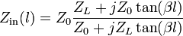 where 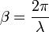 (Equation 3)

Note there are 3 special cases and we will explore each in this lab.

Matched: When Z_{L} = Z₀, then Z_{in} =Z_{L} = Z₀ independent of the length of the line
½ Wave: When L is ½ wavelength, Z₀ vanishes and Z_{in} = Z_{out}
¼ Wave: When L is ¼ wavelength the equation becomes Z_{in} = Z₀² / Z_{L}
Open: also…if one end is infinite (open), the other end appears to be 0
Short: if one end is 0, then the other end appears infinite

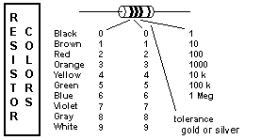
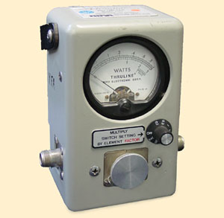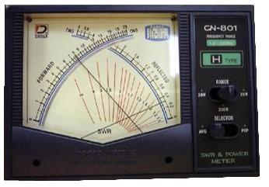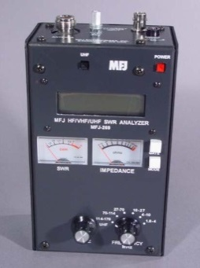

INSTRUMENTATION – SWR Bridge and Antenna Analyzer:

To observe any mismatch on transmission lines, an SWR bridge or a directional Wattmeter is used. The directional Wattmeter (top left) has a reversible sensor so that the forward power and reflected power can be independently measured and the SWR computed using the relationship above. The dual needle meter (top center) measures both forward and reflected power at the same time and the intersection of the needles shows the SWR on the red scale. These devices are sometimes called “SWR bridges” because they measure the difference between a known impedance (50 Ohms for example) and the reflection coefficient of an unknown load. Our instruments are designed to test 50 Ohm systems. Cable and Satellite TV typically use 75 Ohm systems.
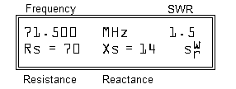
The third instrument, on the right above, is an Antenna Analyzer. It has an internal frequency source and SWR bridge for comparing the impedance of an attached line or load. The LCD display (example pictured here) shows the frequency, the SWR and the R and X components of the complex impedance. Two analog meters also show the SWR and magnitude of |R+jX| impedance for easy tuning. Note: With no action, it goes to sleep to save battery power. Press GATE to awaken it.

Lab Setup: There are 2 setups of parts A, C and D and 1 setup of B, E and F. Stations A, E, and F are the bottle necks. The lab parts are as follows:

Part A. Characteristic Impedance: In this experiment you will measure the effect on SWR of several different lines and different load impedances under four conditions: with no coax (zero length), with 50 Ohm line, with a 75 Ohm line and with a very long 50 Ohm line. Your objective is to make subjective observations of the behavior of SWR and impedance with varying frequency, from which you will be able to draw conclusions regarding impedance matching. Create a table similar to the one pictured below to assemble your observations. Indicate in the ? columns whether the values are relatively consistent (=) or Varying (V and show range). If there is a sharp peak or null in SWR, note this as well as the corresponding frequency. One thing to take away from this part of the lab is that your measurements will not exactly match those of other lab teams. Impedance matching is a fine art that requires testing and some amount of trial and error due to the fact that power transfer efficiency is very sensitive to the slightest changes in line impedance and/or length, load impedance and often frequency.

We have filled in some obvious data (50 Ohms should be a good 1:1 match to 50 Ohm line always. Notice that without any line, the data is all relatively constant with no line (no frequency/wavelength effect). You should see some interesting effects in the other boxes. The highlighted ones should have interesting effects. Your Table and observations should be included in the lab report.

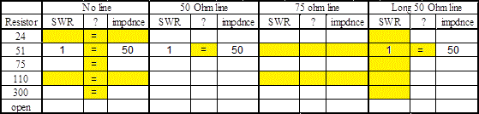

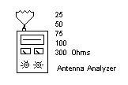
- No Line: Set the Antenna Analyzer to “Impedance R and X” by pressing the MODE key and tune to about 55 MHz. Make sure the UHF button is not pressed in and the frequency range knob indicates 27-70 MHz. Then observe the infinite SWR and high impedance, regardless of frequency, of an open circuit without any transmission line attached. Next, connect in-turn, a 24, 51, 75, 110 and 300 Ohm resistors (i.e. loads) directly to the analyzer using the short double-female BNC adaptor and Resistor connector. During each measurement, TUNE from about 27 to 70 MHz and notice any significant frequency effects on SWR or impedance.

Note: When taking measurements on the antenna analyzer, the analog and digital readouts may not match exactly, so pick one in order to remain consistent with your measurements. The digital readout may allow for a more accurate discrete measurement, but the analog meter allows one to observe how fast the SWR changes with changing frequency. With no length of coax, these first measurements should theoretically show no frequency effect; but the effects will be greater in later steps. Which load has the lowest SWR on this 50 Ohm instrument? Does this make sense?
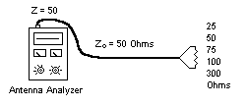
- 50 Ohm Line: Now use a 4 foot, 50 Ohm line (RG-58 (thin)). Measure the length and compute the frequency where this line is ¼ wave in coax (use a typical coax velocity factor of 66%, since light travels at 66% of the normal speed when traveling through coaxial cable). Repeat the six measurements with the different loads of part 1. Again, tune from 27 to 70 MHz and note any maxima or minima and if they occur, take your readings at that point. Otherwise, record the data at about 55 MHz.

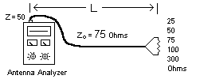
- 75 Ohm Line: Repeat measurements on a 4 foot section of 75 Ohm line (the thicker RG-59 type). Note which value has the lowest SWR when frequency is adjusted for minimum SWR. What is that frequency? Compare this result to the result in Part C.

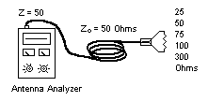
- Long Line: Repeat measurements on the very long coil of 50 Ohm line. Notice the SWR appears to be better (lower), not because the SWR on the line is actually lower, but because the losses in the coax attenuate the reflection from the far end and this makes the SWR “appear” to be lower when in fact, it is not. This is a common error made by those who are not RF engineers or who have not had this course.

- Post Lab: What are some of the key lessons learned with regard to:
- Having the load match the Z₀ of both the line and the source equipment?
- Achieving the best impedance match as indicated by SWR measurements?
- What appears interesting about the blocks highlighted compared to the others?
- The amount of fine-tuning/testing needed in real-world transmission line applications?
- Creative ways to achieve low SWR even if source and load impedances are not the same by fine-tuning the transmission frequency and length of line?
Are these conclusions supported by observations from other parts of the lab?

Part B. Combining RF Loads or Splitting RF Power: Very often in electronics, power on a transmission line has to be shared or combined among two or more loads. At low frequencies, where the length of the wire is very small with respect to wavelength, things can be connected in parallel with simple wire connections. But at RF frequencies, any attempt to parallel loads must take into account the impedance of the line, its length and the transforming effects of mismatched loads.

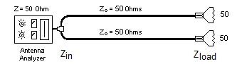
1. Paralleling Coax: Connect two 50 Ohm loads with two 4 foot 50 Ohm lines directly to the antenna analyzer with a T connector as shown here. The two 50 Ohm line/loads in parallel (at the T connector) will result in a 25 Ohm effective load, which has a 33% reflection coefficient in our 50 Ohm system. Notice the SWR ____ and the Impedance _____. The SWR should be about the same SWR you measured when you used only a 25 Ohm resistor in part A. Vary the frequency and note the SWR should remain poor across all frequencies because the lines are matched (themselves) and the mismatch is right at the Analyzer. Lesson: You cannot simply connect matched RF lines with a “T” connector and still have a match!

2. Quarter Wave Transformers: Here is how we could do it. If we can somehow transform the two 50 Ohm loads up to two 100 Ohm loads at the T then they will parallel to a matched 50 and we have a matched system.. We can do this easily by using the complex transformation effect of a ¼ wave length of line to transform each 50 Ohm load to 100 Ohms at the T using the special case of equation 3, Zin * Zload = Z₀² .
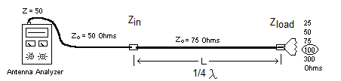
Given we want Zin to be 50 and Zload to be 100, solving for Z₀ gives about 71 Ohms which is real close to the standard 75 Ohm line that is readily available. You demonstrated this in Part A with a 100 Ohm Load as shown here. You do not need to connect this up again, this is just showing you how this impedance transformation works.

3. Phasing Lines: Now replace the two 50 Ohm lines in step 1 with two 75 Ohm lines which still have 50 Ohm loads on the ends and are ¼ wave long as shown below. You should see a very low SWR and an impedance near 50 Ohms.
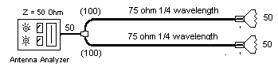
Use the TUNE knob to find the minimum SWR frequency which should occur where the 75 Ohm lines are ¼ wave long. Remember from part A to include the 66% velocity factor in your line length calculations. Calculate the useable bandwidth of this system by the range of frequencies over which the SWR remains below 1.5. ______.

In this example, you have built what is often called a “phasing line or harness” to match two 50 Ohm loads together and still maintain a 50 Ohm match. Notice that the length of the two “phasing lines” must be ¼ wavelength at the frequency of operation for this match to occur. A phasing harness is often used on spacecraft to split or combine power from two or more antennas or loads. Sometimes this function is packaged in a small box and called either a “splitter” or “combiner”.

4. Post-Lab work: Using iterations of the diagram above, sketch how you might design a phasing harness using ¼ wave phasing lines to combine four 50 Ohm antennas to a single 50 Ohm line.

Part C. Quaterwave Notch Filters: (2 Setups). You can use a similar ¼ wave transformation effect as a notch filter (i.e. a filter that significantly reduces/eliminates the transmission of a specific frequency). Since a ¼ wave line that is open on one end will reflect a short to the other (look at the ¼ wave transformer equation in part B to see why), you can connect this “stub” with a “T” connector and at one frequency where the line is exactly ¼ wave, the signals on the line will be shorted. To demonstrate this, connect a signal generator and spectrum analyzer (S/A) as shown below. The spectrum analyzer sweeps across a range of frequencies to show the amplitude against frequency. [All S/A’s have a null “signal” at “zero” frequency, ignore it and any negative frequencies].
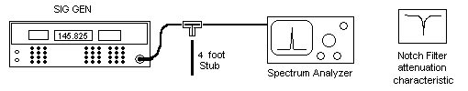
Connect the signal generator to the spectrum analyzer without a stub connected to the “T” and set both for a 0 dBm level centered at about 41 MHz. Set SPAN WIDTH to 5 MHz/div. You should be able to tune the signal generator from about 20 to 60 MHz and see very little change in amplitude of the signal delivered to the spectrum analyzer. Use the FREQ coarse/fine and up/dn buttons for tuning. Record this level for comparisons in the following steps.

- Now “T” in a 4 foot line (green tape). Compute the frequency for which it is ¼ wave and tune to that frequency. Remember to include the shortening effect of the dielectric constant of the line (usually 66%). Tune around that frequency to find the maximum attenuation (minimum signal). Use the coarse/fine and up/dn buttons for tuning the sig-gen in 1 and 0.1 MHz steps as needed. What is the deepest attenuation of this simple “1/4 wave notch filter” in dB (difference with and without the stub connected)? Note, the characteristic Z₀ impedance of this stub does not matter. Why?

What does this tell you about leaving unterminated lines in any test configuration of multiple cables?

- Any line that is an odd multiple of ¼ wave will produce a similar notch at 3, 5, etc times higher frequencies (Why?). Tune the sig-gen to higher odd multiple harmonic frequencies and follow with the spectrum analyzer and you should find multiple attenuation notches at these odd harmonics. However, at higher frequencies, the stub line appears “longer” and so will have more and more loss in the stub. This reduces the effectiveness of the reflected “short” and so the attenuation is not as great. This stub filter makes a nice “comb” filter for taking out all the odd harmonics of a particular set of frequencies. What is the depth of the attenuation at the ¾ and 5/4 wave frequencies?
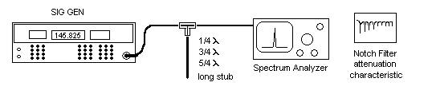

- A Network Analyzer combines a sig gen and spectrum analyzer into one box and sweeps in frequency to simplify observation of a filter. The display will show all the notches as shown above right. Proceed into the R121 Lab and observe the same ¼ wave stub filter as it appears on an RF Network Analyzer. Press the Marker button and select Marker 1 (hit enter). Rotate the knob to note the frequencies of maximum attenuation (nulls) just like you found in step 2 above. Disconnect the stub cable (leaving just the short BNC barrel connector) and notice now only one null around 900 MHz (the length of the barrel connector). Now remove the barrel and see how even that null goes away. There is still a higher null due to the ½” stub remaining but it is off the right end of the screen above 1200 MHz.. Connect the short 1 foot coax and see the null around 145 MHz. Otherwise, the frequency response of the coax is now perfectly flat across all frequencies (though more lossy at higher frequencies). This is why you do not use “T’s” in setting up RF tests, unless you take all this into account.

Part D. Half-Wave Lines:

You can back-to-back two ¼ wave lines so that the first complex transformation will be reversed by the second one resulting in an exact duplication of the original impedance every ½ wave down a line. Think about the graph of a sine wave to intuitively understand why this is so. This can also be shown mathematically by using the equation in part B twice, where the Z_{out} of one ¼ wave line is the Z_{in} of the other. This means that a ½ wave line will virtually “disappear” as far as its characteristic impedance is concerned. You can use this special feature to match an impedance from point A to point B inside a system without worrying about matching the line impedance…. just make the line exactly ½ wavelength long. Note: this is a valuable test technique since you don’t have to worry about mismatches as long as the cable is ½ wavelength long.
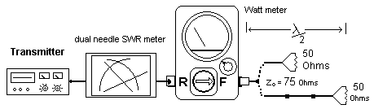
To demonstrate, you will use a 5 Watt CB transmitter at 27 MHz into a 50 Ohm load but using various lengths of 75 Ohm cable (a mismatch). You will use a Navy wattmeter and a dual-needle SWR meter. The Wattmeter measures forward and reflected power that you then convert to SWR using Equation 1 given on page 2. The dual-needle watt meter measures forward and reflected power simultaneously and has a red grid for observing SWR directly from the two readings.

- The 50 Ohm load is already connected to a short piece of 75 Ohm coax. Connect it to the wattmeter and measure the SWR by reading the 27 MHz TX power (Channel 1) in the forward and reverse direction (rotate the watt-meter sensor with the arrow). Compute the SWR using the equation on page 2. Compare your measured SWR to that in Part A for a 50 Ohm load on a 75 Ohm mismatched line. Compare your computed SWR value to that observed on the dual needle SWR meter.

- Now insert one (and test), and then two 4’ long 75 Ohm blue coax lines and again measure the forward and reflected power and compute the SWR. You need to key the transmitter for a full 5 seconds to get very weak readings to show up (the reflected power is near zero when the line is matched). Add up the total length of the 3 sections and compute the ½ wave frequency. Remember to account for the 66% velocity factor that makes the coax shorter than ½ wave in free space. Is this length close to ½ wavelength at 27.0 MHz (Channel 1)? Make this last SWR measurement again on channel 40 (27.4 MHz) to see any difference across the 40 channel CB band.

- Post Lab: What are the advantages and practical uses of ½ wave lines? How do your measurements and observations support your findings?
Part E. Cable Loss (GPS):
In general, the higher the frequency, the greater the signal attenuation for a given length of transmission line. To get higher in frequency where cable loss is more apparent, we will use a GPS receiver out on the Plaza. Long cables waste power in transmit systems and weaken signals in receive systems. This experiment demonstrates cable loss using two lengths of coaxial cable at the GPS operating frequency of 1575 MHz. At this high frequency, even short cables have measurable loss.
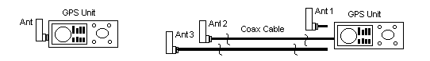
- Lab Period: (Plaza): Set the GPS to the satellite signal strength page:
- Connect the antenna directly to the GPS and hold the unit clear of all objects. Allow a minute for the receiver to obtain a fix. Record the relative signal strength and note the positions of the satellites. Assume the top line on the display is the 0 dB reference and each line is -3 dB from the line above.
- Now move the antenna to the end of the 18’ length of small RG-58 cable and connect it to the GPS. Allow a minute for the receiver to resume lock. Record the satellite relative signal strengths.
- Next move the antenna to the end of the 16’ length of low-loss RG-8 cable and connect it to the GPS. Allow a minute for the receiver to obtain lock. Record the satellite relative signal strengths.
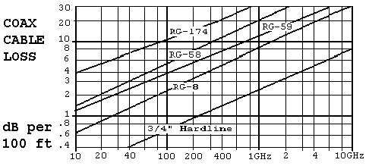
Post-Lab: Compare the measured signal losses to the expected losses (above chart) and to each other. How does your data compare and what does it suggest about the importance of cable selection?

Part F. Cable Loss and Low Noise Amplifiers (LNAs): In this section you will use a Navy UFO satellite as a signal source to study the effects of cable loss on the signal-to-noise ratio (SNR) that determines receive side performance. You will make several signal and noise measurements with and without the LNA at each end of the cable. For consistency, use the 6th transponder from the left of the several UFO channels. Notice that the LNA is a short barrel about the size of your thumb mounted in-line at the antenna end of the coax.
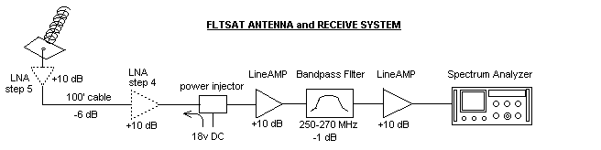
- Lab Period: (Plaza/Lobby)
With nothing connected to the Spectrum Analyzer(S/A), press the AMPT button and confirm or set HiSensitivity to ON. Press the FREQ button and set the center freq to 256.850. Press the SPAN button and set to 3 MHz. Press the BW/SWP button and set resolution bandwidth to 30 KHz and sweep time to AUTO. Note that the reference level (top line) is now set to – 50 dBm and each vertical division indicates -10 dB down from the top. What is the average noise level of the Spectrum Analyzer? (The RMS average of the noise peaks).
- Now connect the cable to the S/A with the LNA connected out at the antenna, point to the CONUS UFO (220º AZ and 40º EL). We are now tuned to only one of the 10 UFO Navy channels and it is more than 10 dB above the noise floor. Observe the average signal power level _____ and the average noise power level _______and thus, (difference) the Signal-to-Noise ratio (SNR)_______. The noise level is higher now due to the gain of the amps between the antenna and S/A and the contribution of noise from the LNA..
- Now move the LNA from the antenna into the lobby operating position. Connect it in front of the power injector and two line amps where the cable connectors are marked with black tape. Observe the signal level _____, noise level ______, and SNR ______. Notice a similar signal power (still the same number of amps), but the noise level is higher. The difference here is that the cable loss is now in front of the LNA instead of after it so the LNA is amplifying both noise and signal. Comment on the lesson learned here.
- Now remove the LNA and reconnect the cables without it. Observe the signal level_____, noise level _____ and SNR_____ now without the benefit of the LNA. Comment on this observation.
- There are several things to notice here, but the Transmission Line portion of this knowledge is observed as the increase in noise level in step 2 when the LNA is moved from outdoors to indoors (in front or behind the coax loss). The signal power did not change (same total gain), but the SNR went down by the same dB as the loss in the cable which was ______. No amount of additional gain can ever get that back!
- Restore the system, re-connect the two line amps and move the LNA back to the antenna for the next group.

Transmission Lines Laboratory Report: You have made many observations from which you can support the theories about transmission lines and their practical application. Many of the elements of this lab will come back during the antenna lab. In each part of the lab you were told what observations and values to collect and results you should have observed. For this lab, a team lab summary (See the Lab Summary template provided) that documents the answers to the questions and fill-in-the-blanks from each section.
The Lab report must include the names of your team members as well as the dates you conducted the measurments. It should be organized by section. You are not required to provide a procedures section, but you should comment on anything that occurred out of the ordinary, especially if it may have affected your data collection. The Lab Summary should be written as if it was an excerpt from the results section of a full lab, meaning in the style and language of a lab report.

